SPONSORS
Thanks to the institutions that provided the financial support that made this meeting possible.
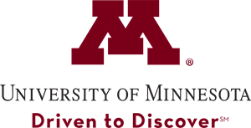
University of Minnesota
Department of Integrative Biology and Physiology
College of Liberal Arts
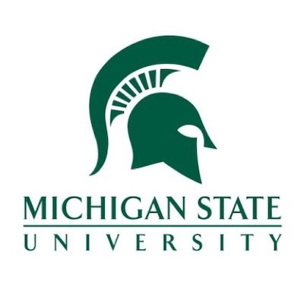

Michigan State University
Department of Physiology
College of Natural Sciences

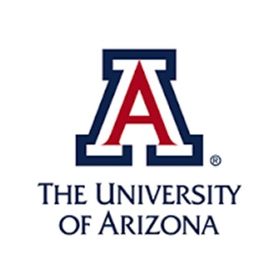
University of Arizona
Department of Physiology
College of Medicine

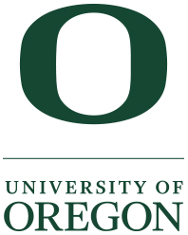
University of Oregon
Department of Human Physiology
College of Arts and Sciences

SPONSORS continued
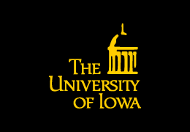
University of Iowa
Department of Health and Human Physiology
College of Liberal Arts and Sciences

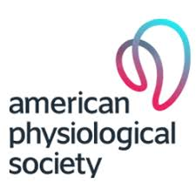

American Physiological Society

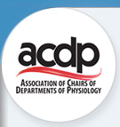

Association of Chairs of Department of Physiology

ADInstruments

P-MIG Groups
PLANNING COMMITTEE
Erica Wehrwein, Michigan State University
Claudia Stanescu, University of Arizona
Jennifer Rogers, University of Iowa
Valerie VanRyn, ADInstruments
James Davis, Indiana State University
Jeffrey Osborn, University of Kentucky
Robin Hopkins, University of Oregon
Vincent Barnett, University of Minnesota
Lisa Carney Anderson, University of Minnesota
Anne Crecelius, University of Dayton
Patrick Crosswhite, Gonzaga University

Core Concepts Working Group – Claudia Stanescu (Co-chair), Jennifer Rogers (Co-chair), Joel Michael, Jenny McFarland, Barry Mason, Julia Choate, Nancy Aguilar-Roca, Patrick Crosswhite, Richard Nichols, Robin Hopkins, Vincent Barnett, Lisa Carney Anderson, Kerry Hull
Professional Skills Development Working Group – Michelle French, Julia Choate, Randy Bryner
Advising Working Group – Anne Crecelius, Patrick Crosswhite
MEETING GOALS
- Inform attendees on the past, present and future goals and activities of the PMIG organization
- Highlight the importance of staff and faculty to the success of undergraduate physiology students
- Share resources, discuss best practices, and provide survey data on advising undergraduate physiology students
- Solicit feedback on a draft of the necessary professional skills for graduating undergraduate physiology students
- Update PMIG on Core Concepts Committee work, share data from Core Concepts curricular inventories, and solicit feedback for future directions
- Share the student perspective through dissemination of results from the 2019 Student Survey
- Recruit additional participants to PMIG working groups
- Work towards national curricular guidelines for physiology undergraduate programs
- Provide a forum for networking of stakeholders in undergraduate physiology education

PROGRAM
TUESDAY JUNE 18, 2019 – 4:30 PM – 7:00 PM
Time | Event
4:30 – 5:00 PM | Registration: 114 Bruininks Hall
5:00 – 7:00 PM | Poster Session: Presenters leave posters for duration of meeting
7:00 PM | Walk to Sally’s Restaurant: Participants responsible for own meal
WEDNESDAY JUNE 19, 2019 – 8:00 AM – 5:00 PM
Time | Event
8:00 – 8:30 AM | Registration, breakfast and networking
8:30 AM – 9:00 AM | Welcome message and introduction  - Joseph Metzger, PhD, Department Chair  - Lisa Carney Anderson, PhD, Co-host, Dir. Of Education
Physiology Majors Interest Group (P-MIG)
Past, Present and Future
- Erica Wehrwein, PhD, P-MIG Director
Michigan State University
9:30 AM – 10:45 AM | Preparing Physiology Students for a Meaningful Career: The role of the teacher/adviser  - Laurence Savett, MD  National Association of Advisors for the Health Professions (NAAHP)  Author of The Human Side of Medicine
10:45 AM – 11:00 AM | Break
11:00 AM – 11:30 AM | Presentation by the Advising Working Group by Group Chairs: Advising the Physiology Student  - Anne Crecelius, PhD  University of Dayton  - Patrick Crosswhite, PhD  Gonzaga University
11:30 AM – 12:00 PM | Discussion Panel: Best Practices in Advising  - Laurence Savett, Anne Crecelius, and Patrick Crosswhite
12:00 PM – 12:30 PM | Lunch
Round Table Open Discussion Grouped by Topic -
Targeted outcome of discussion: What is something PMIG can do to support quality of Advising of Physiology Major?
12:30PM- 1:00PM | Group Photo
1:00 PM – 1:30 PM | Exercise Break - Walking or Bike Rental  Opportunity to view posters
1:30 PM – 2:15 PM | Managing Stress in the Curriculum and in the Culture: The Unique Opportunity for Physiologists  - Aviad Haramati, PhD, Professor, Division of Integrative Physiology, Dept. of Biochemistry, Molecular and Cellular Biology  Director, Center for Innovation and Leadership in Education (CENTILE)
2:15 PM – 2:30 PM | Presentation of Professional Skills Group by Group Chairs: Clarifying Professional and Technical Skills for Physiology Majors  - Michelle French, PhD  University of Toronto  - Randy Bryner, PhD  West Virginia University
2:30 PM – 3:00 PM | Small group discussion of Professional Skills Template
3:00 PM – 3:15 PM | Break
3:15 PM – 3:45 PM | Regroup and consensus building on Professional Skills
3:45 PM – 4:00 PM | Next steps for Professional Skills Template  - Michelle French, PhD
4:00PM – 4:15 PM | Break
4:15 PM – 5:45 PM | Panel Discussion: The Future of Physiology – Teaching and Practice: Development of Strategic Scenarios for 2030  - Monteiro (Luis) Rodrigues, PhD  Professor and Chair of Human Physiology and Pathophysiology  Universidade Lusófona
4:30 PM – 5:00 PM | Group Photo
5:00 PM – 6:00 PM | Free time for exercise, rest or networking
6:00 PM – 8:00 PM | Appetizer buffet on the Patio of the Campus Club  Entertainment by the Lisa Carney Anderson Trio
THURSDAY JUNE 20, 2019 – 8:00 AM – 12:00 PM
Time | Event
8:00AM – 8:30 AM | Breakfast, networking and posters
8:30 AM – 9:30 AM | Presentation from the Core Concepts Work Group by Group Chairs: What are the core concepts, how should we use them, how will we assess them?  - Claudia Stanescu, PhD  University of Arizona  - Jennifer Rogers, PhD  University of Iowa
9:30 AM – 9:45 AM | Video Conference Presentation: Curriculum Alignment Made Easier: Quickly Identify Content Overlaps and Gaps in Your Course or Program  - Chris Shaltry, PhD  Michigan State University
9:45 AM – 10:00 AM | Break
10:00 AM – 11:00 AM | Table Discussion for Core Concepts
11:00 AM – 11:30 AM | The University of Minnesota’s Career Readiness Curriculum with the U of MN’s Career Readiness Team  - Judith Anderson, Director of Career Readiness  - Kris Cory, Career Readiness Faculty Engagement Specialist  - Wendy Rahn, PhD, Political Science
11:30 AM – 12:00 PM | Q and A Discussion  - University of Minnesota CLA Career Readiness Team
12:00 PM – 1:00 PM | Box lunches
Invitation to next meeting July 2020
(Robin Hopkins, University of Oregon)
Recruitment of new members to Work Groups
Wrap up discussion
1:00 PM – 2:00 PM | Leadership meeting (all are welcome)

ABSTRACTS

1 | Reading the Signs of the Times: Reorganization of Health and Sports Science Degree Programs, Anne Crecelius, University of Dayton
2 | Developing Learning Progressions for Flux and Mass Balance Reasoning In Physiology, Mary Pat Wenderoth, University of Washington
3 | Reflective Writing as a Learning Tool to Improve Exam Performance in a Clinical Physiology Course, Lisa Carney Anderson, University of Minnesota
4 | Adaptive Active Learning Will Improve Student Outcomes and Teaching in Principles of Physiology (PHSL 3061/5061), Steven Wu, University of Minnesota
5 | Extreme Physiology – The Ultimate Outdoor Classroom, Terrence Sweeney, The University of Scranton
6 | Muscle Spindles and Our Sense of Physical Self: Kinesthetic Mirages of Limb Position and Posture, Brandon Calderon, ADInstruments
7 | Report for the Physiology Majors Interest Group (P-MIG): Faculty Surveys on Core Concepts of Physiology, Claudia Stanescu, University of Arizona
8 | Results from the 2019 P-MIG Student Survey, Jennifer Rogers, University of Iowa
9 | The Core Concepts in an Undergraduate Physiology Curriculum: Meeting Diverse Pre-Professional Needs at St. Olaf College, Sarah Amungongo, St. Olaf College
10 | Physiology in the Liberal Arts Biology Curriculum: Serving Majors, Pre-medical and Pre-veterinary Students, Anne Walter, Sarah Amugongo, & Kevin Crisp, St. Olaf College
11 | Intervention to Address Freshman Retention in Exercise Physiology, Randy Bryner, West Virginia University
12 | Offering Retakes to Improve Learning Outcomes, James Davis, Indiana State University
Special Thanks to the Home Team!

Meeting Recording – Steven Wu
Bike Tour – Dalay Olson
Student Support – Gavin Fredrickson
Clerical Support – Jean Otto, Jane Barnard, Andy Johnson

